TWIC USER MANUAL

Welcome to Twic
One place to converse and pursue interests. Twic members can send short (no more than 140 characters) messages to other members and can keep tabs on those things that interest them. All that is needed to join is an email address. To get started visit the website.

Registration
When the website is visited you will see a login page. If you are not a member of Twic you will need to click the “Register” button, located in the upper right of the browser window, to be taken to the registration form.
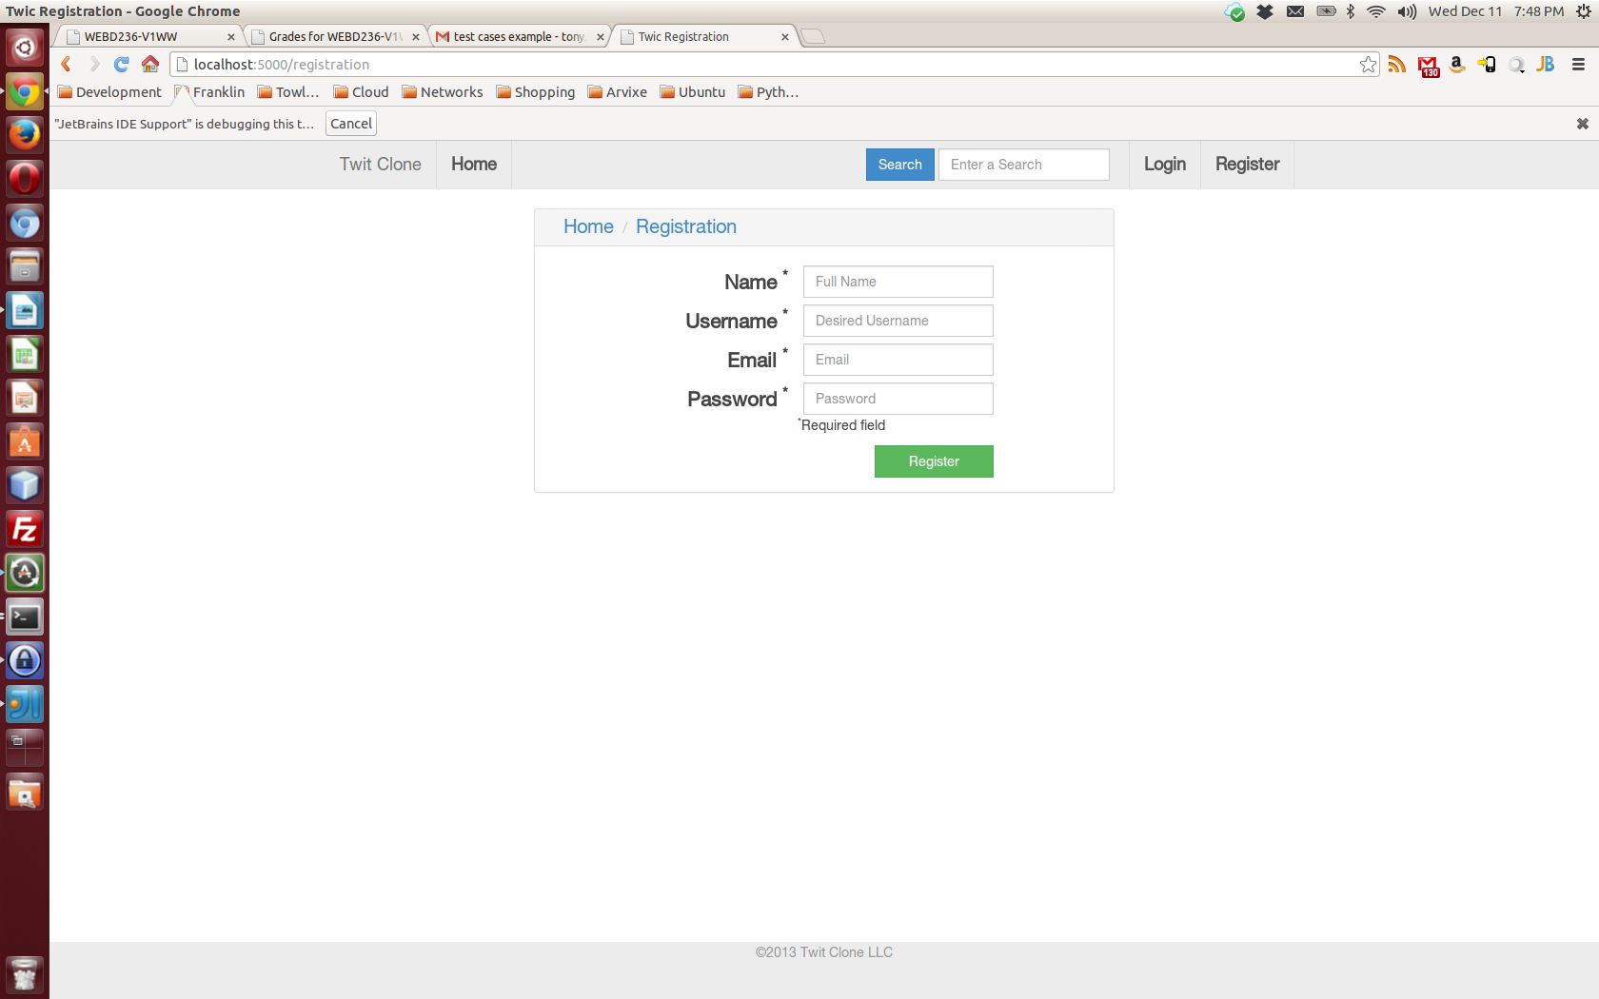
The registration page requires the entry of your name, desired username, email address, and a desired password. After all of the fields are complete then clicking the green “Register” button will complete the process and allow you to begin posting messages.

Login
If you are already registered then you can login using the page that you see when you visit the website. Just enter your username or email address and your password whenever you are ready to begin posting messages.
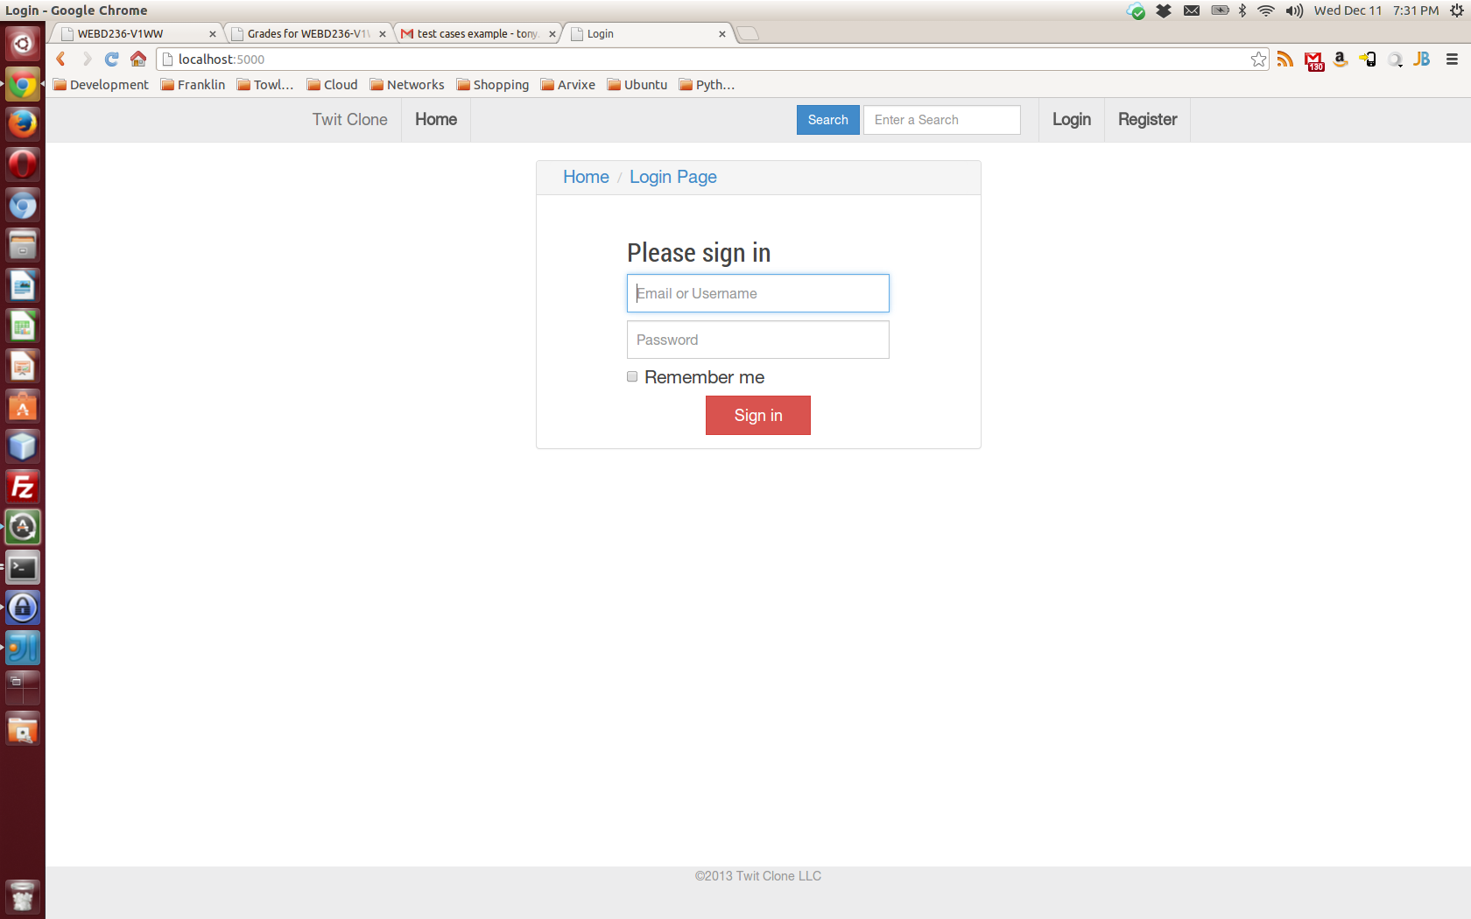
Clicking the red “Sign In” button will complete the login process.

Dashboard
After the registration or login process you will see your dashboard. The dashboard is where messages can be posted or viewed.
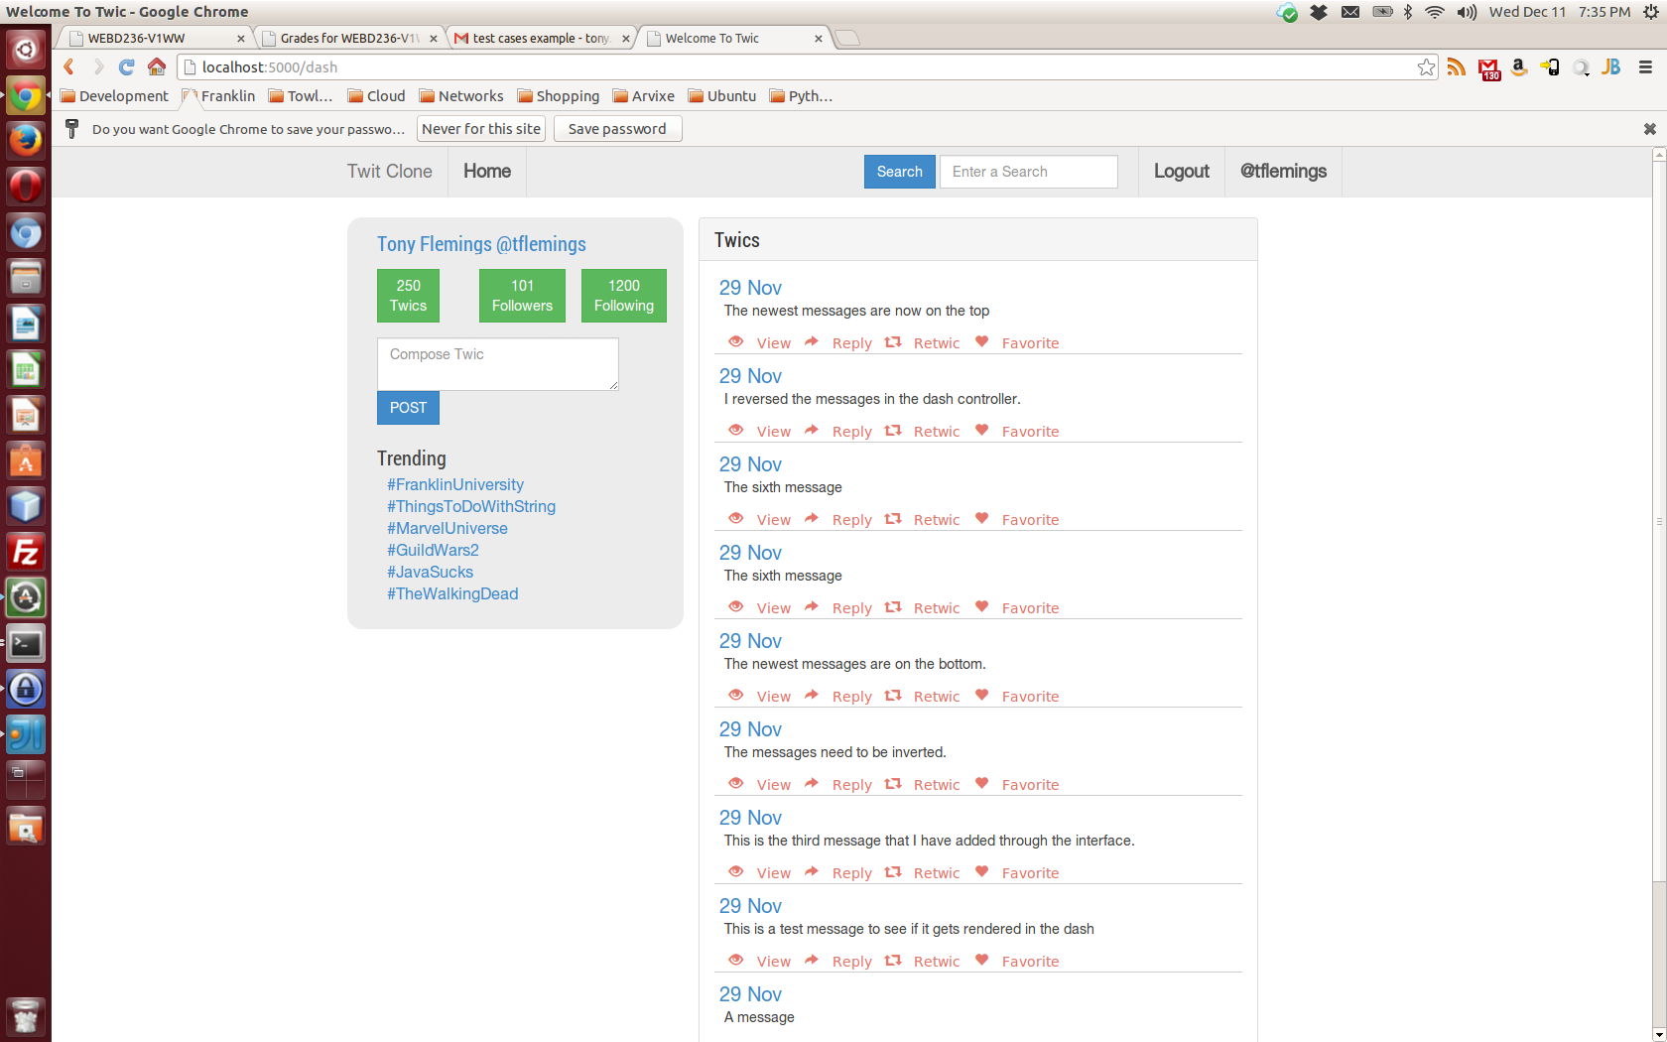
The left side of the dashboard contains information about your account such as how many messages you have posted, how many other members you are following, and how many members are following you. Below the account information is a tool to post a new message. Typing the message into the text box and clicking the blue “POST” button will send the message. The newly created message will then appear in your list of recent messages.

The right side of the dashboard contains your most recent messages in descending date order. From the list of messages there are four options for each. You can view the entire message, reply to a message, report the message, or mark the message as a favorite so that you can track the message.

Logging Out
At any time you can press the “Logout” button at the top of the browser window to logout of the website. To see new messages you will need to login again.

